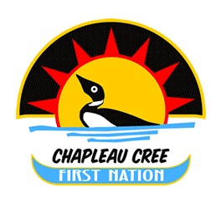
Spring Clean Up Days
Chapleau Cree First Nation

Public Works Garage staff will be collecting household waste and other garbage on

Tuesday, May 29th, 2018
&
Wednesday, May 30, 2018

All household waste is to be bagged in green “type” garbage bags.

Please ensure items are accessible and separated into piles for collection:
Electronics
Batteries
Propane bottles and/ or tanks (unless the valves have been removed)
Metal
Wood Waste
Tires (limit 4 per household)

Deadline date for garbage to be picked up is
Wednesday, May 30th, 2018.
Garbage will not be picked up after this date and will be home owner’s/tenant’s responsibility.

Call Shane @ 705-221-1533 to request
pick-ups for derelict vehicles

