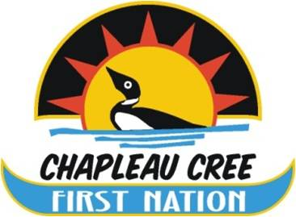

P.O. Box 400✦ Fox Lake Reserve✦ Chapleau, Ontario✦ P0M 1K0
Tel: (705) 864-0784 ✦ Fax (705)864-1760
reception@chapleaucree.ca

EMPLOYMENT OPPORTUNITY

Position: Public Works Labourer
Location: The Chapleau Cree First Nation (CCFN) is a member of the Mushkegowuk Council and is situated on the Fox Lake Reserve, located just outside the community of Chapleau. The community is approximately four hours north of Sault Ste. Marie and two hours south/west of Timmins.
Accountability: Chapleau Cree First Nation is seeking a highly motivated, multi-skilled, and experienced person to maintain, repair and perform general upkeep on all property and assets owned and operated by the First Nation. This position is directly managed by the Public Works Garage Supervisor.
Preferred Qualifications
- Valid Class “G” driver’s license
- Minimum 3 year’s experience
- Experience in carpentry/electrical/building maintenance will be an asset.
- Must obtain the ability to work independently with minimal supervision but also act as a team member.
- Ability to prioritize workload, developing maintenance plans, and work schedules.

Requirements of employment may include but not be limited to the successful candidate providing a clear CPIC.

Detailed position descriptions are available at the Chapleau Chapeau Cree First Nation Band Office. All person interested in this position are encouraged to apply. Please provide a cover letter with resume on or before October 23, 2018 at 4:00 PM.

Chapleau Cree First Nation
Box 400
Chapleau, ON
P0M 1K0
Attention: Edith Larocque

bandadmin@chapelaucree.ca

We thank all applicants, but only those selected for an interview will be contacted.
First Nation individuals and CCFN band members are encouraged to apply!

