Kunuwanimano Child & Family Services

NewsLetter
  - Volume 1 / Issue 3 March 6, 2018
In This Edition
- March Break
- Employment
- Alternative Care
- Upcoming Events
- Positive Thinking
- Family Day in Cochrane
- Kids Games

March Break Message
We’d like to wish all the children and families in the communities a happy, safe and fun March Break! Rest well! March break is the week of March 12 – 16, 2018 for *most schools in the area.

Employment Opportunities
We are always interested in hearing from passionate Social Workers with an interest in protecting our children and serving our families within our 11 First Nation communities. Interested individuals are invited to submit resumes and cover letters, regardless of any current vacancies listed.
To apply, please send your cover letter and resume to HR@kunuwanimano.com

Benefits of Joining our Team
- Contribute to a unique service model
- Opportunity to learn First Nation cultures and traditions
- Personal Gratification
- Competitive Salary
- Medical/Dental Benefits
- Employee Assistance Programs
- OMERS Pension Plan
- Corporate Wellness & Fitness Membership Rates
- OACAS Training Opportunities
To review current employment opportunities, please visit our website at www.kunuwanimano.com

Alternative Care
We are currently looking for Caregivers within Kunuwanimano, if you have room in your heart you have room in your home. Kunuwanimano means “Keeping Our Own” to strengthen our communities by respecting, practicing, and teaching the traditional ways passed on by our Elders.
Making a Difference – Every day, foster families make real differences in our communities. You can make a difference – join our team!
If you are interested in becoming a caregiver please contact our agency at 705-268-9033 and request to speak to Intake.

Upcoming Events
Full Moon Ceremony Schedule 2018
Date | Time
Saturday March 31st | 7:00 p.m.
Sunday April 29th | 7:00 p.m.
Tuesday May 29th | 7:00 p.m.
Thursday June 28th | 7:00 p.m.
Friday July 27th | 7:00 p.m.
Sunday August 26th | 7:00 p.m.
Monday September 24th | 7:00 p.m.
Wednesday October 24th | 7:00 p.m.
Friday November 23rd | 7:00 p.m.
Saturday December 22nd | 7:00 p.m.

Everyone is invited to participate in the Full Moon Ceremonies and women are asked to bring a skirt to wear during the ceremony. Please bring tobacco and yellow broadcloth as an offering. Moon time protocols will be followed and children are welcome.
LOCATION: The location will be determined on a monthly basis. Please contact Mary or Alice to confirm location.
Contact Information:
Mary Boyden 705-266-3215 or at mary.boyden@gmail.com
Alice Sutherland 705-365-0459 or at asuther1@outlook.com

Events in Cochrane:
Monday March 12:
Nutrition Bingo from 12-3pm
TTN Complex
Lunch Menu – Tacos
Tuesday March 13:
Board games from 1-3pm
TTN Complex
Snacks & Beverages provided
Wednesday March 14:
Movies & Crafts from 12-3pm
TTN Complex
Lunch Menu: Spaghetti
Thursday March 15:
Family Swim 3-5pm
THEC
*Parents must accompany their children
Friday March 16:
TTN Family Dance 7 – 9PM
TTN Complex
Music brought to you by C & Izzy Sound & Music

For more information please contact Alice Skead at (705) 272-2729 ext, 1307 or Liz M. Sutherland at (705)272-3933
Chapleau District Office  522 Hwy 129, PO. Box 96, Chapleau Ontario P0M 1K0  MARCH BREAK ACTIVITIES  DRUM STICK WORKSHOP  Friday, March 16/18  Location: Brunswick House-Health Center  Time: 1:00-4:00 pm  Drum materials will be provided for everyone  Food and beverages will be served  FAMILY SKATING PARTY  Saturday, March 17/18  Location: Chapleau Arena  Time: 2:00-4:00 pm  *Helmets required for children*  Food and beverages will be provided for everyone  FAMILY SLIDING/PIZZA PARTY  Sunday, March 18/18  Location: Chapleau High School  Time: 2:00-4:00 pm  Pizza and beverages will be provided for everyone  Bring your crazy carpets/sleds if you choose not to enter the cardboard sled contest  CONTEST!!! Bring your best homemade cardboard sled!!  For more information please contact: Ruby Taylor or Vanessa Bedard at (705) 268-9033 | Bus Schedule  Saturday, MARCH 17TH  Location:  BHFN-Health Center 1:30  CCFN-Health Center  1:45  Sunday, MARCH 17TH  location:  Bhfn-health Center 1:30  CCFN-health center  1:45  Bus will drop off families at same location after 4 pm  *Contest *  Best homemade cardboard sled wins mystery prize! (value $100.00)  Come on out and have some outdoor fun!!  All parents and families are welcome to join us!!
Events in Kirkland Lake District: A few events coming up in the district:
March 10 @ 9:00am – Saturday Morning Cartoons and Big Breakfast (admission is a small donation, held at Riverside Community Church in Swastika)
March 12 @ 2:15-3:15 – Kunuwanimano’s Prevention Services has rented the Pool at the complex (Town of Kirkland Lake) for a Family Swim on March 12 2018 @ 2:15 to 3:15.
March 18 @ 1-5:00pm – Positive Birth Prenatal Workshop (held at King Street Fitness, $30/ couple)

Positive Thinking
Contact Us
Kunuwanimano Child and Family Services
38 Pine St. N., Unit 120
Timmins, ON P4N 6K6
Tel: 705-268-9033
Toll Free: 1-800-461-1293

7 MUSKRAT Mindset to Get Unstuck
From Muskrat Magazine’s websitE, muskratmagazine.com
pOSTED by: Zainab Amadahy
Ever feel like you’re in a rut? Unsure about how to make change? Waiting for that key ingredient to arrive before you move, only it never comes? We all get stuck now and then. Feeling stuck can be frustrating and depressing. Here are some mindset hacks to break out of your stuckness. See which ones work for you.
- “Stuck” is an illusion.
The world moves constantly. Life moves in cycles. Fast/slow. Activity/rest. Day/night. Seasonal cycles. Monthly cycles. Stuckness can be seen as part of your life cycle. It is a temporary slowness, an energetic low. You’re not stuck when you’re asleep or resting. We need times of rest, rejuvenation & reflection. You can feel frustrated in those times or welcome and enjoy them. Stuckness is just a feeling. Like all feelings it comes and goes. Rest assured this, too, shall pass.

- Take responsibility.
STOP blaming or finding excuses. In blaming someone or something for your situation you give up your power. There may, indeed, be obstacles, situations and circumstances you have no control over. Nevertheless, you still have the power to make changes in your life anytime you want. Focus on what you CAN do rather than what you can’t.

- Find meaning.
Your feelings of stuckness have a reason for existing. You can investigate that reason, learn from it and move forward. Allow yourself to feel “stuck” without judgment. No “shoulds”. No shame. Just observe. Feel your feelings as they rise and fall. Does any information land?

- Change it up.
This feeling of stuck is doing you a favor. It’s showing you that something in your life isn’t working. If you’ve been busy nonstop, racing around trying to achieve your aspirations, stop. Be still and see what lands. On the other hand, if you’ve been still, waiting for opportunities to come and they haven’t, start moving. Take a small step in any direction. See how it feels. Step back, sideways or forward and test the water. Feel where you are. Is it better or worse than where you were? Figure it out, decide the direction you’re going to move in next and take another step.
- Everyone feels stuck from time to time.
Maybe this moment can help you be more compassionate and understanding of others who are experiencing a form of “stuckness”. Maybe you can help someone else. You just might help yourself in the process. Like the saying goes, you can’t splash perfume on others without getting a bit on yourself.

- Accept & Trust.
Feel free to stop trying to change what is. The Universe will open the right door at the perfect time. This isn’t it. Maybe you’re being protected from something. Maybe there’s something even better than you can imagine in the works. Can you trust and accept divine timing?

- Find joy.
Don’t let the anxieties you feel in one area of your life prevent you from enjoying other aspects of being alive, like sunsets, music, good food, friendships, whatever. Forget about being stuck and go have fun. In the end, remember that you give meaning to your life experiences. You can let your stuckness feel insurmountable or you can consider it a moment of learning. Your decision. Best wishes with it.

Family Day In Cochrane
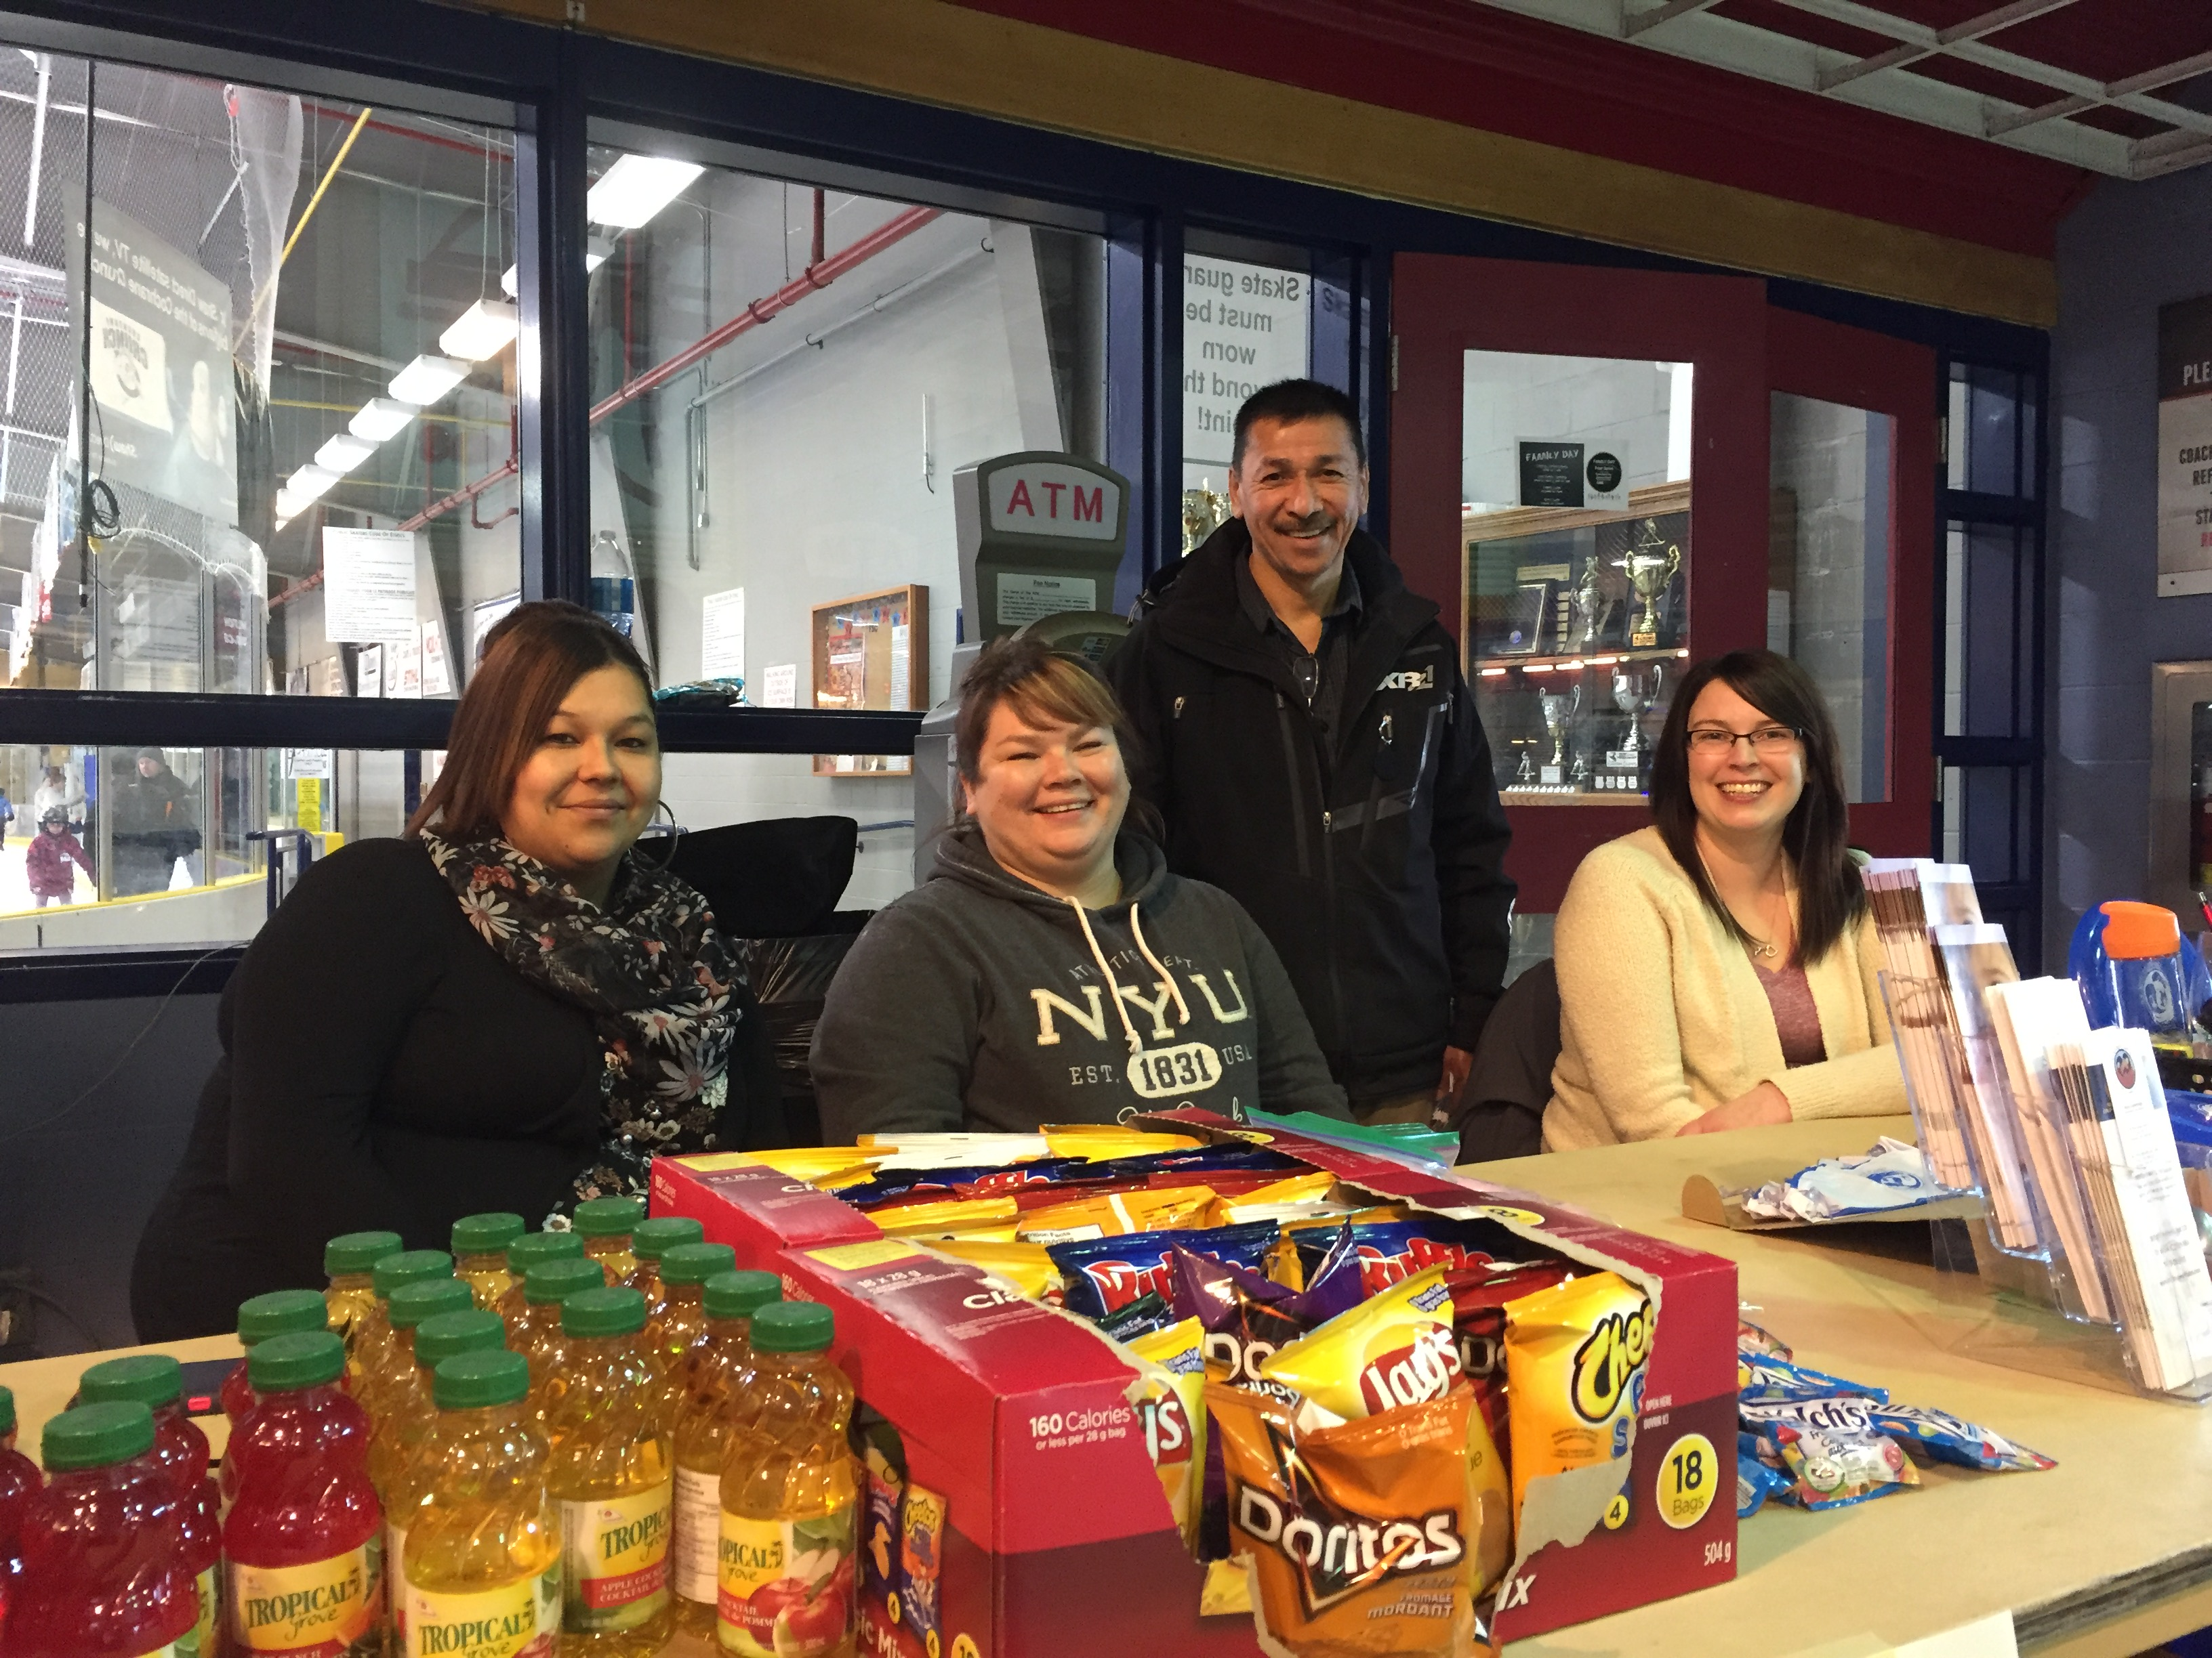

The Cochrane District Office was all set up at the Tim Horton’s Event Center to provide information on becoming a caregiver as well as to provide children and families with snacks at the free skating event that took place on Family Day, Feb. 19th, 2018. (Left to Right: Charlene Chakasim (volunteer), Sabrina Vincent, Program Supervisor, Roger Archibald, Board of Directors, Chair, and Kyla Cummings, Alternative Care Worker.

